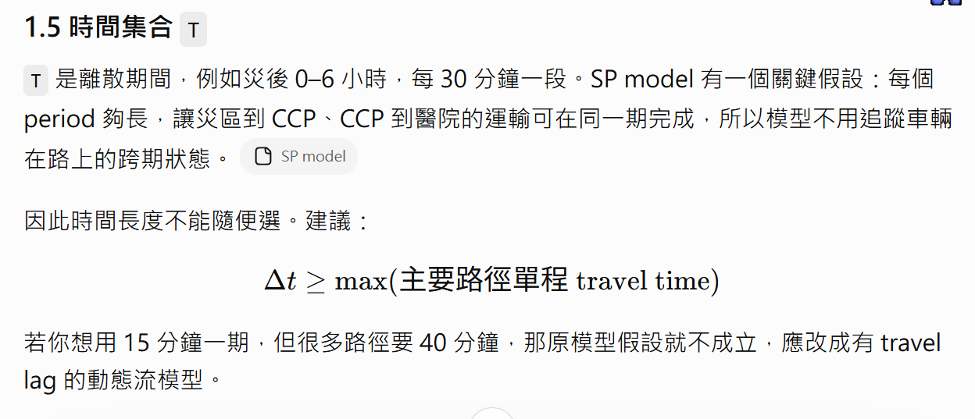
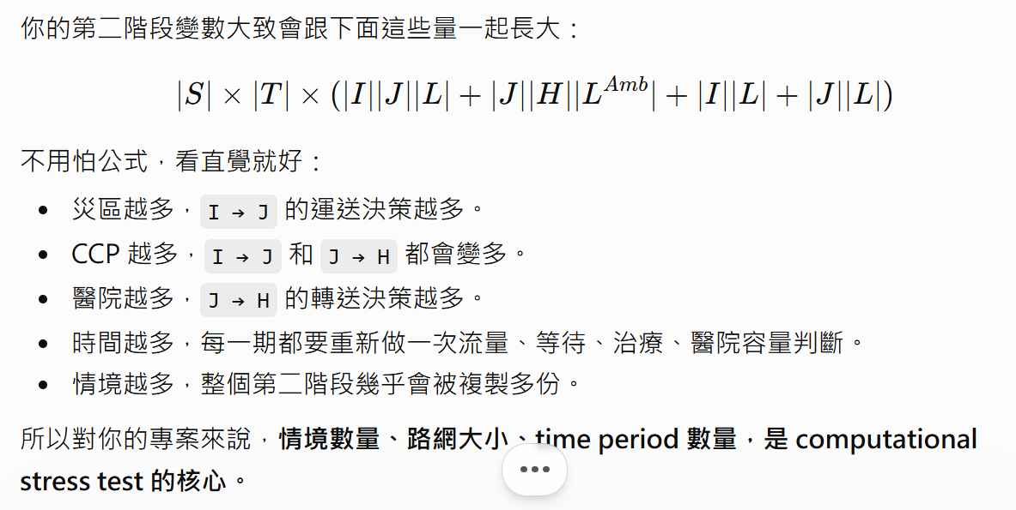
$$ω^{s}=\left(ξ_{ilts},u_{ijts},w_{jhts},h_{hts}\right), ∀s∈S$$
$$Q_{s}=Q\left(X,V,U,Y;ω^{s}\right), ∀s∈S$$
假設一期30分鐘

3.3 Sets, Parameters, and Decision Variables
Sets:
$$I$$ | Set of disaster areas, indexed by $i$. | 10
$$J$$ | Set of candidate CCP locations, indexed by $j$. | 5
$$H$$ | Set of hospitals, indexed by $h$. | 4
$$L$$ | Set of casualty severity levels, indexed by $l$. Specifically, it includes minor, moderate, and severe levels.
$$L^{Amb}$$ | Subset of casualty severity levels that require ambulance transportation and hospital transfer (i.e., moderate and severe casualties), $L^{Amb}⊆L$.
$$T$$ | Set of discrete time periods, indexed by $t$.
$$S$$ | Set of post-disaster scenarios, indexed by $s$.
First-Stage Deterministic Parameters:
$$f_{j}$$ | Fixed cost of opening CCP j, $∀j ∈J$ . | 3,000,000
$$cv$$ | Unit cost of assigning one medical staff member to a CCP. | 10,000
$$ca$$ | Unit cost of assigning one CCP ambulance to a CCP. | 8000
$$cy_{hj}$$ | Unit cost of allocating one unit of medical supplies from hospital $h$ to CCP $j$, $∀j∈J$, $∀h∈H$. | 1800
$$nv$$ | Total number of available medical staff members. | 30
$$na$$ | Total number of available CCP ambulances. | 12
$${\overline{s}}_{h}$$ | Maximum amount of medical supplies that hospital $h$ can provide, $∀h∈H$. | 350
$$\overline{v_{j}}$$ | Maximum number of medical staff members that can be assigned to CCP $j$, $∀j∈J$. | 18
$${\overline{u}}_{j}$$ | Maximum number of CCP ambulances that can be assigned to CCP $j$, $∀j∈J$. | 3
$${\overline{y}}_{j}$$ | Maximum amount of medical supplies that can be assigned to CCP $j$  , $∀j∈J$. | 300
Second-Stage Deterministic Parameters:
$$c_{ij}$$ | Normal maximum transportation capacity (casualties/period) on the road link from disaster area $i$ to CCP $j$, $∀i∈I,j∈J$. | Distance(m) x 0.08
$$c_{jh}$$ | Normal maximum transportation capacity (casualties/period) on the road link from CCP $j$ to hospital $h$, $∀j∈J,h∈H$. | Distance(m) x 0.05
$$κ$$ | Number of ambulance-requiring casualties that one CCP ambulance can transport in one period. | 2
$$η$$ | Number of casualties that one hospital ambulance can transfer in one period. | 2
$$b_{h}$$ | Number of ambulances owned by hospital $h$, $∀h∈H$. | 3
$$k_{jl}$$ | Physical capacity of CCP $j$ for casualties of severity level $l$, $∀j∈J,l∈L$. | Minor: 50; Moderate: 15; Severe:5
$$τ_{l}$$ | Number of periods required to treat one casualty of severity level $l$ at a CCP, $∀l∈L$. | minor: 1; moderate: 2; severe: 1
$$α_{l}$$ | Number of casualties of severity level $l$ that one medical staff member can treat in one period, $∀l∈L$. | minor: 3; moderate: 2; severe: 1
$$β_{l}$$ | Amount of medical supplies consumed by one casualty of severity level $l$, $∀l∈L$. | minor:1; moderate:2; severe:4
$$ρ_{l}$$ | Unit penalty cost for one casualty of severity level $l$ remaining in a disaster area for one period, $∀l∈L$. | minor:2000; moderate:50000; severe:100000
$$δ_{l}$$ | Unit penalty cost for one treated casualty of severity level $∀l∈L^{Amb}$ waiting at a CCP for hospital transfer for one period, $∀l∈L^{Amb}$. | minor:0; moderate:25000; severe:50000
$$t_{ij}$$ | Unit transportation cost, or cost-equivalent travel time penalty, for transporting one casualty from disaster area $i$ to CCP $j$, $∀i∈I,j∈J$. | 100 + 150 x distance(m) / 1000
$$t_{jh}$$ | Unit transportation cost, or cost-equivalent travel time penalty, for transferring one casualty from CCP $j$ to hospital $h$, $∀j∈J,h∈H$. | 100 + 150 x distance(m) / 1000
Random Variables:
$${\overset{˜}{ξ}}_{ilt}$$ | Random variable representing the number of newly generated casualties of severity level $l$ in disaster area $i$ during period $t$. Its realization in scenario s is $ξ_{ilts}$. | Demand multiplier  Baseline: Demand multipler = 1  每一期救出的傷患數量 ~ U[0,10] x demand multiplier  輕、中、重傷機率 = [60%, 30%, 10%]
$${\overset{˜}{u}}_{ijt}$$ | Random variable representing the available capacity proportion ([0,1]) of the road link from disaster area i to CCP j during period t. Its realization in scenario s is $u_{ijts}$. | Road capacity multiplier  Baseline: Demand multipler = 1  第一期：U ~ [0,0.4]  道路恢復速率：U ~ [0.05,0.08]  之後每一期道路連通率都是第一期 + 道路恢復速率x (t-1)  直到最大值是1就不能再更大了
$${\overset{˜}{w}}_{jht}$$ | Random variable representing the available capacity proportion ([0,1]) of the road link from CCP j to hospital h during period $t$. Its realization in scenario $s$ is $w_{jhts}$. | Road capacity multiplier  Baseline: Demand multipler = 1  第一期：U ~ [0,0.4]  道路恢復速率：U ~ [0.05,0.08]  之後每一期道路連通率都是第一期 + 道路恢復速率x (t-1)  直到最大值是1就不能再更大了
$${\overset{˜}{h}}_{ht}$$ | Random variable representing the maximum number of casualties that hospital $h$ can receive during period $t$. Its realization in scenario $s$ is $h_{hts}$. | Hospital capacity multiplier  第一期醫院容量 ~ U [12, 25]  之後每期容量都是前一期 x 0.9
First-Stage Decision Variables:
$$X_{j}$$ | $X_{j}∈\left\{0,1\right\}$,1 if CCP $j$ is opened, and 0 otherwise, $∀j∈J$. | integer
$$V_{j}$$ | Number of medical staff members assigned to CCP $j$, $∀j∈J$. | integer
$$U_{j}$$ | Number of CCP ambulances assigned to CCP $j$, $∀j∈J$. | integer
$$Y_{hj}$$ | Amount of medical supplies allocated from hospital $h$ to CCP $j$, $∀j∈J,h∈H$. | integer
Second-Stage Decision Variables:
$$FI_{ijlt}\left(s\right)$$ | Number of casualties of severity level$l$ transported from disaster area $i$ to CCP $j$during period $t$ under scenario $s$, $∀i∈I,j∈J,l∈L,t∈T$. | continuous
$$FO_{jhlt}\left(s\right)$$ | Number of casualties of severity level $l∈L^{Amb}$ transferred from CCP $j$ to hospital $h$ during period $t$ under scenario $s$, $∀j∈J,h∈H,l∈L^{Amb},t∈T$. | continuous
$$RM_{ilt}\left(s\right)$$ | Number of casualties of severity level $l$ remaining in disaster area $i$ at the end of period $t$ under scenario $s$, $∀i∈I,l∈L,t∈T$. | continuous
$$REG_{jlt}\left(s\right)$$ | Number of casualties of severity level $l$ registered at CCP $j$during period $t$ under scenario $s$, $∀j∈J,l∈L,t∈T$. | continuous
$$TRT_{jlt}\left(s\right)$$ | Number of casualties of severity level $l$ under treatment at CCP$j$ during period $t$ under scenario s, $∀j∈J,l∈L,t∈T$. | continuous
$$WAT_{jlt}\left(s\right)$$ | Number of treated casualties of severity level $l∈L^{Amb}$ waiting at CCP$j$ for hospital transfer at the end of period $t$under scenario s, $∀j∈J,l∈L^{Amb},t∈T$. | continuous

